GENERAL DIRECTIONS FOR STATIONS:
- 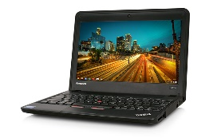TAKE TO EACH STATION:
- 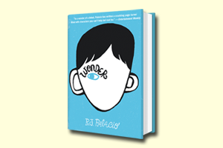CHROMEBOOK & HEADPHONES
- PENCIL
- YOUR INDEPENDENT READING BOOK
- RESPONSE SHEET
- EEOD – Everything Else Off Desk (other students will be sitting at your desk)
- Read the directions at each station before you begin.
- If you have a question, ask a group member BEFORE you ask a teacher.
- COOPERATE, BE RESPECTFUL, WORK HARD
- If you finish a task early, you may read or create a magnetic poem (Mrs. H.’s web site/Poetry/ magnetic poetry button)

