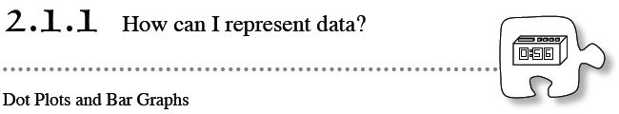
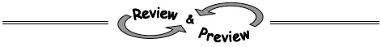
- 2-6. For the problem below, display the data using a dot plot, bar graph, or Venn diagram. Decide which type of data display is best and explain why. Homework Help ✎
Appliances sold at Housemart during the month of September:
Washers: 35 Dryers: 21 Ovens: 19
Refrigerators: 27 Dishwashers: 23
- 2-7. Elizabeth wants to challenge you to a “Toothpicks and Tiles” game. Using exactly 6 tiles, solve her challenges below. Justify your answers with pictures and labels. 2-7 HW eTool (CPM) Homework Help ✎
  - Find a pattern where the number of toothpicks is more than double the number of tiles.
  - Find a pattern where the number of toothpicks is 4 more than the number of tiles.
- 2-8. On a hot summer day, Leo and Stefano decided to buy some refreshments at the Fruit and Smoothies store. Fruit kabobs cost $1.75 each and smoothies cost $2.50 each. Homework Help ✎
  - Leo ordered two fruit kabobs and one smoothie. How much did he spend?
  - Stefano ordered three fruit kabobs and four smoothies. How much did he spend?
  - Arturo could not decide, but he had $9.00 he could spend on fruit kabobs and smoothies. He knows he wants at least one of each. What are some combinations he can afford? (Show at least three possibilities.)
- 2-9. Lulu is playing “Toothpicks and Tiles” from Lesson 1.1.2. She has arranged 10 tiles as shown below. She wants to rearrange them so that the number of toothpicks remains the same. Draw one possible arrangement of the tiles. 2-9 HW eTool (CPM) Homework Help ✎
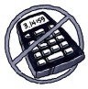
- 2-10. Add or subtract. Remember to line up the decimal point. Homework Help ✎
  - 53.199 − 27.61
  - 155.96 + 56.232
  - 83.617 − 36.518
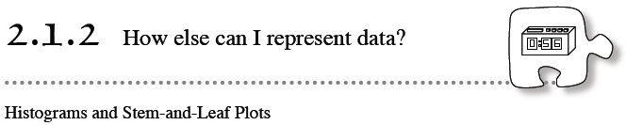
- 2-15. Copy the sequences and fill in the missing numbers. Explain the pattern in words. Homework Help ✎
  - 5, 14, 23, 32, 41, ____, ____, ____
  - 3, 6, 12, 24, 48, ____, ____, ____
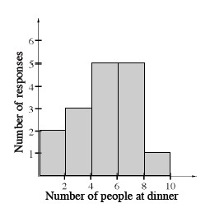
- 2-16. Lyn asked some of her classmates how many people are normally at home for dinner.
She recorded her results in the histogram shown at right.
Homework Help ✎
  - How many classmates were surveyed?
  - How many classmates have eight or nine people at home for dinner?
  - Can you tell which is the most common number of people at home for dinner? Why or why not?
- 2-17. Maria was putting together party favors (small bags of treats for each person) for her niece’s birthday party. In each bag, she put three small chocolate candies, and four hard candies. If Maria had 12 bags, how many candies did she use in all? How could you represent this with a number expression? Homework Help ✎
- 2-18. How many different rectangles can you draw with an area (number of “tiles”) of 28? What is the perimeter (number of “toothpicks”) of each one? Show your work. 2-18 HW eTool (CPM). Homework Help ✎
- 2-19. Ms. Katz paid $50 for a used bicycle and then sold it to her neighbor for $60. She decided to buy it back, but she had to pay $70 for it. If she then sold it again for $80, how much money did she make or lose overall? Show your solution in enough detail so a teammate could easily understand how you found your answer. Homework Help ✎
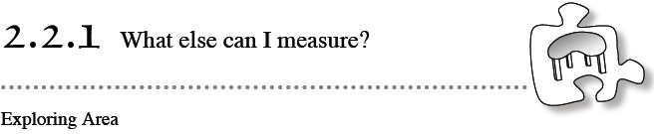
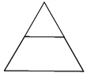
- 2-24. Lakisha made a giant triangle using two pattern blocks: one green triangle and one red trapezoid. Homework Help ✎
  - What is the area of the entire shape if the green triangle has an area of 1 square cm?
  - What is the area of the entire shape if the red trapezoid has an area of 1 square inch?
- 2-25. Find the area of the shape below that was cut from graph paper. Use square centimeters as your units. The problem has been started for you. Homework Help ✎
- 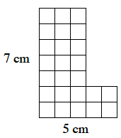
- 2-26. Multiple Choice: Which of the following measures could describe the area of a desk? Explain how you know. Homework Help ✎
A. 4 square inches | B. 4 square feet
C. 4 square meters | D. 4 square miles
- 2-27. Copy and complete the stem-and-leaf plot below for the following set of data: 64, 87, 52, 12, 17, 23, 45, 88, 45, 92, 62, 76, 77, 34, and 53. Homework Help ✎
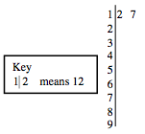
- 2-28. Add or subtract. Homework Help ✎
  - 9.67 + 49.7 + 5.22
  - 4.2 + 1.903
  - 97.1 − 35.04
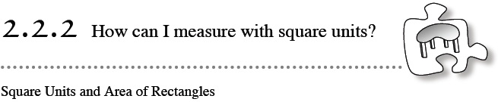
- 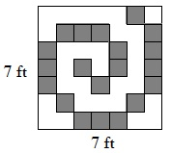2-34. Assume that the shaded tiles in the large square at right each have an area of one square foot. Use this information to answer the following questions. Homework Help ✎
  - What is the total area of the shaded squares?
  - What is the total area of the un-shaded squares?
  - Find the total number of square feet of area in the figure in two different ways.
- 2-35. Hector measured the area of his desktop by covering it with quarters (25¢ coins). Can he find the area using these circular units of measure exactly, or will he have to estimate? Explain your answer. Homework Help ✎
- 2-36. Use the numbers 2, 3, and 4 and the operations (mathematical processes) of addition, subtraction, multiplication, or division to create three different numerical expressions with three different values. One of the expressions should have a value of 14. Homework Help ✎
- 2-37. What is the best way to display the data below? Why? Display the data using the method you chose. Homework Help ✎
Daily high temperature for Honolulu, Hawaii in December of 2009:
83, 83, 81, 82, 80, 83, 81, 82, 79, 83, 84, 82, 81, 81,
80, 81, 84, 80, 80, 81, 81, 82, 80, 79, 78, 80, 84, 82, 82, 81, 83
- 2-38. Find the missing number that makes each of the following number sentences true. HHomework Help ✎
  - 15 · ? = 90
  - 6 · ? = 96
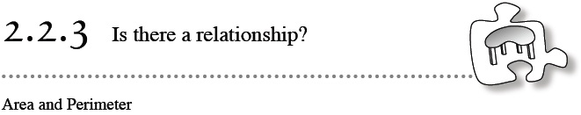
- 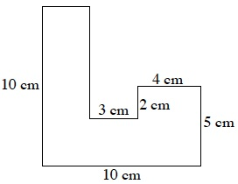2-46. Find the area and perimeter of the figure at right. All angles are right angles. Show all of your work. Homework Help ✎
- 2-47. Draw and label two different rectangles, each with perimeters of 20 units. Do the rectangles have the samearea? Explain your thinking. 2-47 HW eTool (CPM). Homework Help ✎
- 2-48. Think about the Base Ten blocks you used during the lesson. Using 1 hundred block, 3 ten blocks, and 6 one blocks, create a shape with the largest possible perimeter. Remember that the blocks need to be touching along a side, not connected at a corner. Sketch your solution and show all of your work. 2-48 HW eTool (CPM). Homework Help ✎
- 2-49. Given the data in the table below, copy and complete the histogram below to represent families of various sizes. Remember that data falling on a tick mark (3, 6, 9, …) goes in the bin to the right of that mark. What range do most families fall between? What range do most families fall between? Do you see any families that are much larger or much smaller than other families? Homework Help ✎
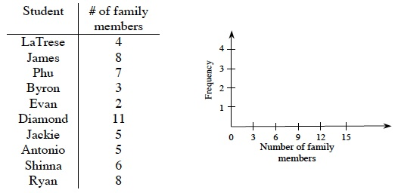
- 2-50. Consider the units in this list: inches, centimeters, feet, yards, meters, kilometers, and miles. For each situation given below, list the units that would be most commonly used to measure the length or distance described. Homework Help ✎
  - Distance from Bellingham, WA, to Washington, DC.
  - Length of a small stuffed animal.
  - How far you walk during lunchtime at school.
  - Height of your classroom.
  - Length of your shortest fingernail.
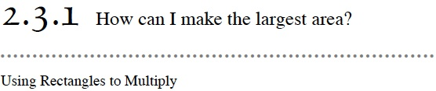
- 2-55. Draw a generic rectangle to multiply 37 · 42. Homework Help ✎
  - Write an equation using addition that shows the total area of the generic rectangle.
  - Multiply 37 · 42 by using the standard algorithm for multiplication. That is, place one of the numbers under the other and use the procedure for multiplication that you were taught in previous courses. Show your work. Compare your result with your answer from part (a).
  - Which method of multiplication do you prefer? Why?
- 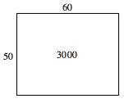2-56. Riley is looking at the diagram at right in his math book. Identify the factors and product represented by the rectangle. Homework Help ✎
- 2-57. Use your understanding of equivalent fractions to write two fractions that are equivalent to each of the following fractions. Homework Help ✎
- 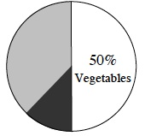2-58. Ruth’s brother, Ethan, planted a garden for her as a surprise while she was away. He planted seeds for vegetables in 50% of the garden. He also planted flowers and herbs. Homework Help ✎

- The entire circle in the graph at right represents the area of Ruth’s garden. If the lightly shaded portion represents flowers, estimate what percentage of the garden could be herbs. Explain your estimate.

- 2-59. Add or subtract. Homework Help ✎
  - 34.62 + 74.8
  - 213.09 − 37.2
  - 3.15 + 36.8 + 7
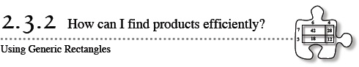
- 2-65. 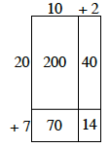Draw a generic rectangle to help you calculate each product. For each part, write: (total dimension)(total dimension) = sum of individual area parts = total area. For example, the diagram at right shows that (12)(27) = 200 + 40 + 70 + 14 = 324. Homework Help ✎
  - (73)(42)
  - 125 · 81
- 2-66. Copy and complete the table of multiples below (count by 3’s and count by 4’s). Extend the table so that it has 14 columns of values. Homework Help ✎
Three | 3 | 6 | 9 | 12
Four | 4 | 8 | 12
  - Write down all the numbers that appear in both rows. Describe any pattern(s) that you notice.
  - What is the smallest multiple of both 3 and 4?
  - Write three more numbers that are multiples of both 3 and 4.
- 2-67. Jenny has been saving her babysitting money for a class field trip to Washington, D.C. She wants to save $200.00 over three months. She saved $53.00 the first month and $67.00 the second month. Homework Help ✎
  - Estimate (without calculating) the amount that Jenny needs to earn during the third month to meet her goal.
  - Now show how Jenny could calculate the amount of money she needs to earn.
- 2-68. Find three fractions that are equivalent to three-eighths. Explain your method. Homework Help ✎
- 2-69. Janelle and three of her friends bought four smoothies for a total of $3. If she purchases smoothies on another day for herself and nine of her friends, how much money will she spend? Homework Help ✎
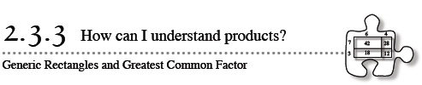
- 2-75. Solve each generic-rectangle puzzle. For each part, write a multiplication sentence, as you did in problem 2-72. Homework Help ✎
  - 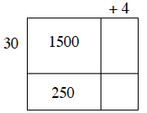
  - 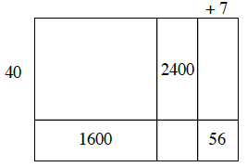
- 2-76. James is painting his 10-by-8-foot bedroom wall that contains a 2-by-3-foot window. Homework Help ✎
  - Draw a diagram of his wall and the window.
  - How many square feet of wall does he need to paint?
- 2-77. Figure out whether each of the following pairs of fractions is a pair of equivalent fractions. Be sure to show all of your work or explain your thinking clearly. Homework Help ✎
  - and 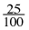
  - and
  - and
- 2-78. Misty and Yesenia have a group of Base Ten Blocks. Misty has six more blocks than Yesenia. Yesenia’s blocks represent 17. Together they have 22 blocks, and the total numbers of blocks represent 85. What blocks could each girl have? What is the value? Homework Help ✎
- 2-79. COMPARING WAYS TO REPRESENT DATA.
- Use the golf-tournament data below to complete parts (a) through (e). Homework Help ✎
- Ages of golfers participating in a golf tournament:
- 44, 48, 40, 25, 28, 37, 29, 34, 45, 51, 43, 35, 38, 57, 50, 35, 47, 30, 63, 43, 44, 60, 46, 43, 33, 45, 42, 34, 32
  - Use the data to create a dot plot.
  - Why is a dot plot not the best choice for graphing this data?
  - Create a stem-and-leaf plot for the data.
  - Use the stem-and-leaf plot to create a histogram for the data.
  - What range of ages do most golfers fall between? Do you see any ages that are much larger or smaller than other ages?
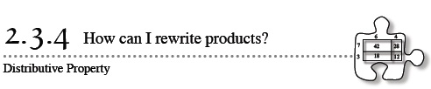
- 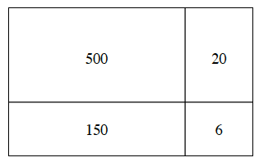2-86. Look at the generic rectangle at right. Homework Help ✎
  - What two numbers are being multiplied using this rectangle? How can you tell?
  - Write the product as a sum of the areas and find the answer.
  - Use the Distributive Property to write an equation showing that the product is equal to an expression with parentheses, multiplication, and addition.
- 2-87. In Section 2.1, you learned how to create dot plots, bar graphs, histograms, and stem-and-leaf plots. Which of these representations would best display the data given below? Use that representation to display the data. Homework Help ✎
- Boot sizes of the Math Marching Team:
- 10, 8, 12, 10, 10, 9, 10, 11, 12, 8, 8, 9, 10, 11,
- 10, 9, 11, 11, 12, 11, 10, 11, 8, 10, 12, 8
- 2-88. The following number lines are missing some numbers. Sketch each one on your paper and use the information provided to complete the number lines. Homework Help ✎
  - 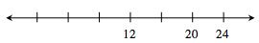
- 2-89. For each of the following problems, complete the fraction on the right so that the fractions are equal. Be sure to show your work clearly. Homework Help ✎
  - 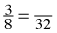
  - 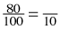
  - 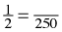
- 2-90. This problem is a checkpoint for addition and subtraction of decimals. It will be referred to as Checkpoint 2.
- Add or subtract the following decimals. Homework Help ✎

  - 2.95 + 18.3 + 11
  - 9.2 − 0.375
  - 0.275 + 27.5
  - 90 − 0.903
- Check your answers by referring to the Checkpoint 2 materials.
- If you needed help solving these problems correctly, then you need more practice. Review the Checkpoint 2 materials and try the practice problems. Also consider getting help outside of class time. From this point on, you will be expected to do problems like this one quickly and easily.

