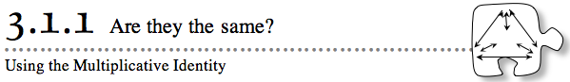
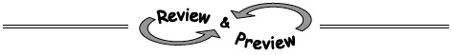
- 3-12. Copy and complete each of the following Giant One problems. Homework Help ✎
  - 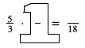
  - 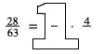
  - 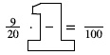
- 3-13. Rachel says that when she ran 115 yards, she went farther than Beth, who only ran 327 feet. Is Rachel correct? Explain how you know. Remember that 1 yard = 3 feet. Homework Help ✎
- 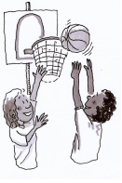3-14. Look at the two histograms below. They give you information about the heights of players on two basketball teams, the Tigers and the Panthers. Use the histograms to answer the following questions. Homework Help ✎
- 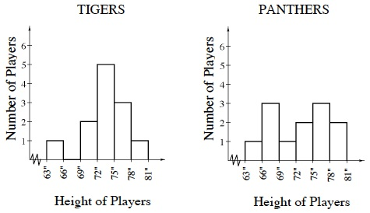
  - Which team has taller players? Which has shorter players? Explain your thinking.
  - Which team has heights that vary more? Explain your thinking.
  - Which team has more players that are about the same height?
- 3-15. Find the measure indicated in each question below. Homework Help ✎

a. Find the perimeter of the triangle. 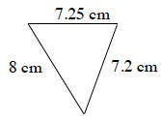 | b. Find the area of the large rectangle. 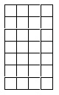
c. Find the area and perimeter of the rectangle below.
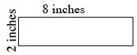
- 3-16. Write down at least three different pairs of numbers that add together to get 1. Homework Help ✎

- 3-17.Use the Distributive Property to rewrite each of the expressions below. Then simplify. Homework Help ✎
  - 12(309)
  - 8(100 + 10 + 8)
- 3-18. If five notebooks cost $5.25, how much would three notebooks cost? Homework Help ✎
- 3-19. Jing Ya takes the bus across town to school each morning. Last week, he timed his trips and found that the time varies day to day. The times (in minutes) are listed below. Homework Help ✎
- 15, 10, 11, 13, 11
  - If you had to use one number to tell someone how long it took Jing Ya to get to school, what would you say?
  - Jing Ya does not want to be late. If he needs to get to school by 8:00 a.m. each day, what is the latest time he should get on the bus (assuming one is waiting for him at any given time)? Explain how you got your answer.
- 3-20. Study the dot pattern below. 3-20 HW eTool (CPM). Homework Help ✎
  - Draw the 3rd and 5th figures.
  - How many dots will there be in the 50th figure?
  - Is there a figure that will have exactly 38 dots? If so, which figure is it?
- 3-21. Stacy exercises three days each week by walking around the soccer field near her home. The field is 80 yards wide and 115 yards long. Homework Help ✎
  - Draw a diagram of the field. Then find how far Stacy walks in one trip around the field. This distance is called the perimeter.
  - If Stacy walks around the field four times each time she exercises, how far does she walk each week?
  - Additional Challenge: A mile is 1760 yards. How many miles does Stacy walk each week?
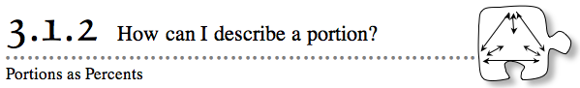
- 3-31. For each of the following portions, draw a diagram of the mixture in the jar. Then shade a layer that would correspond to this portion of raisins. Finally, order these portions from least to greatest. Homework Help ✎
  - 40%
  - 25%
- 3-32. At Cassie’s Cashew Shoppe, a sign says, “Today only: 20% off anything.” Maribel realizes that she has a coupon for off the price of anything in the shop. Which discount should she use, the 20%-off deal or the -off coupon? Does it matter? Explain. Homework Help ✎
- 3-33. Maribel is taking advantage of the sale at Cassie’s Cashew Shoppe. She wants to figure out how much she will save on a purchase of $34. Maribel’s percent ruler is shown below. Copy the ruler on your paper and help her figure out what 20% of $34 is. Homework Help ✎
- 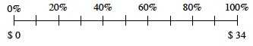
- 3-34. As you have discovered, any fraction can be rewritten in many equivalent ways. When choosing a denominator that will work to add two fractions, there is no single correct choice. Often, people find it convenient to use the smallest whole number that all denominators divide into evenly. This number is called thelowest common denominator.
- For example, when adding the fractions , you could choose to rewrite each fraction with 48 or 96 in the denominator. However, the numbers will stay smaller if you choose to rewrite each fraction with a denominator of 24, since 24 is the lowest number that 3, 6, and 8 divide into evenly. (Dividing into a number evenly means that there is no remainder.)
- For each of the following sums, first rewrite each fraction using the lowest common denominator. Then add. Read the Math Notes box in this lesson for additional help. Homework Help ✎
- 3-35. Find the following sums or differences. Homework Help ✎
  - 12.35 + 1.08
  - 8.02 − 0. 64
  - 568.38 − 134.21
  - 0.29 + 0.92
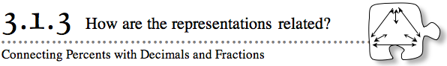
- 3-45. An article in the local paper states that 30% of the students at Oak Grove Middle School earned a place on the Silver Honor Roll. If there are 920 students at Oak Grove, how many are on the Silver Honor Roll? Use a percent ruler to help you decide. Show all of your work. Homework Help ✎
- 3-46. Given the following descriptions of portions, write each portion as a percent. Use a 100% block to help you visualize the portions. 3-46 HW eTool (CPM). Homework Help ✎
  - 3 tenths and 6 hundredths
  - 8 hundredths
  - 17 hundredths
  - 11 tenths
- 3-47. Maurice's gas tank can hold 60 liters of gas. On your paper, copy and label the percent ruler below. Then use it to find how many liters are in the tank when it is: Homework Help ✎
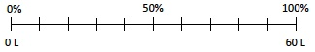
  - 50% full
  - full
  - full
- 3-48. Which of the following fractions could you add together easily? Explain. Homework Help ✎
- 3-49. Alex earns $7.75 a day by walking dogs for his neighbors. If he walks dogs for 12 days, how much money will he make? Show how you got your answer. Homework Help ✎
- 3-50. Use the Lesson 3.1.3B Resource Page to shade in the amounts represented by the following descriptions, and then write them in the stated form. 3-50 HW eTool (CPM). Homework Help ✎
  - Shade 7 hundredths, and write the portion as a percent.
  - Shade 7 tenths, and write the portion as a fraction.
  - Shade 28%, and write the portion as a fraction.
  - Shade 31.5%, and write the portion as a decimal.
- 3-51. Given the numbers 18% and 0.7, explain which number is larger by using words and/or pictures. Homework Help ✎
- 3-52. Explain what 78.5% would look like on a 100%-block. Then write it as a decimal. Homework Help ✎
- 3-53. What is the sum of ? Represent your ideas in multiple ways. Homework Help ✎
- 3-54. Owen loves to eat hamburgers. He goes to his neighborhood grocery store to buy ground beef and buns to make hamburgers at home. He buys a package of hamburger buns for $1.29 and a package of ground beef for $5.82. He only has a $10 bill and wonders if he can buy some ketchup and mustard, too. The ketchup is $1.89, and the mustard is $2.69. He does not have to pay sales tax on food. Homework Help ✎
Does Owen have enough money to buy both the ketchup and the mustard? If he does, how much money will he have left over? If not, then what could he buy and how much would it cost?
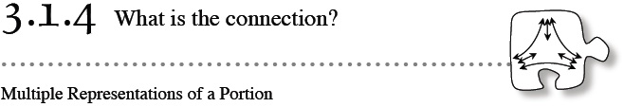
- 3-62. Add or subtract the following fractions. Homework Help ✎
- 3-63. Copy the incomplete axes and fill in the missing numbers to make the scaling consistent. Homework Help ✎
- 3-64. For each of the representations below, write the portion in each of the forms listed. Remember that a hundred block now represents 100%. Homework Help ✎
  - Percent
  - Decimal
  - Fraction
  - Description in words
  - 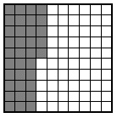
  - 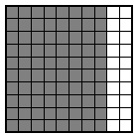
  - 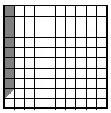
  - 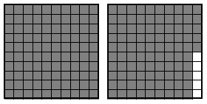
- 3-65. Estimate the amount of gas left in this car’s gas tank with a fraction. Homework Help ✎
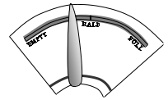
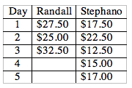
- 3-66. Randall and Stephano work in a restaurant. Randall earned $27.50 one day, $25.00 the next day, and $32.50 on the third day. Stephano works fewer hours, but more days. He earned $17.50 one day, $22.50 the next day, $12.50 the third day, $15.00 the fourth day, and $17.00 the fifth day. Who earned the most money? How much more? Homework Help ✎
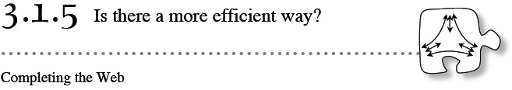
- 3-73. In this lesson, you looked for ways to convert between equivalent forms of fractions, decimals, and percents. Using the portions web, write the other forms of the number for each of the given portions below. Show your work so that a team member could understand your process. Homework Help ✎
  - Write as a decimal, as a percent, and with words/picture.
  - Write 0.30 as a fraction, as a percent, and with words/picture.
  - Write 85% as a fraction, as a decimal, and with words/picture.
  - Write one and twenty-three hundredths as a percent, as a decimal, and as a fraction.
- 3-74. Maya and Logan each made up a “Guess my Decimal”game just for you.
Use their clues to determine the number. Homework Help ✎
  - Maya gives you this clue: “The decimal I am thinking of is 3 tenths greater than 80%. What is my decimal?” Show your work.
  - Logan continues the game with this clue: “My decimal is 3 hundredths less than 3 tenths.” Use pictures and/or words to show your thinking.
- 3-75. Amanda and Jimmy have jobs as dog walkers. Examine the graph at right and answer the following questions. Homework Help ✎
- 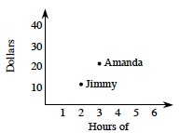
  - Who has more hours of dog walking? How do you know?
  - Who has earned the least amount of money? How do you know?
  - Are both students earning the same amount of money per hour? Show your work to justify your answer.
- 3-76. Preston picked five playing cards and got a 2, 3, 6, 5, and 1. Homework Help ✎
  - What two-digit and three-digit numbers could he create that would have the greatest sum? Is there more than one possibility? What is that sum?
  - What two-digit and three-digit numbers could he create that would have the smallest sum? Is there more than one possibility? What is that sum?
- 3-77. Use the Distributive Property to rewrite each product below. Simplify your answer. Homework Help ✎
  - 28 · 63
  - 17(59)
  - 458(15)
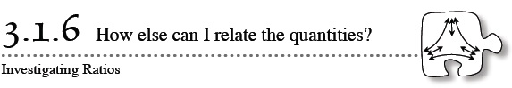
- 3-84. Walter is mixing cement for his new patio. He knows he needs to use a water-to-cement ratio of 20 to 30. What percent of his total mixture is water? Homework Help ✎
- 3-85. David wants to find and is wondering if using decimals can help him make sense of adding fractions. Homework Help ✎
  - How could be written using decimals? What is the sum as a decimal?
  - How could your answer from part (a) be written as a fraction?
  - Rewrite as a fraction that could be added easily to .
- 3-86. Use the data and axes below to create a histogram for Mr. Nguyen’s class grades. Homework Help ✎
- 50, 55, 57, 60, 62, 65, 78, 80, 82, 85, 88, 89, 90, 91, 93, 95, 96, 98, 99
- 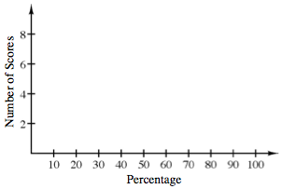
- 3-87. If you walk forward 5 feet and then walk backward 5 feet, you will end up exactly where you started. For each of the actions below, describe an action that will get you back where you started. Homework Help ✎
  - Walk up 10 steps.
  - Earn 8 dollars.
  - It gets 5 degrees warmer.
  - Lose 6 dollars.
  - Travel south 3 kilometers.
  - Run backward 9 steps.
- 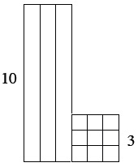3-88. The diagram at right is made up of Base Ten Blocks. Use the diagram to answer the following questions. 3-88 HW eTool(CPM). Homework Help ✎
  - Find the area and perimeter of the shape.
  - Draw a Base Ten Block shape with a value of 126 using the fewest number of blocks possible. Find the perimeter of the shape that you drew.
- 3-94. Lucas’ frog is sitting at −2 on the number line. 3-94 HW eTool (CPM). Homework Help ✎
  - His frog hops 4 units to the right, 6 units to the left, and then 8 more units to the right. Write an expression (sum) to represent his frog’s movement.
  - Where does the frog land?
  - What number is the opposite of where Lucas’ frog landed?
- 3-95. Draw and label a set of axes on your graph paper. Plot and label the following points: (1,3), (4,2), (0,5), and (5,1). Homework Help ✎
- 3-96. Rewrite each product below using the Distributive Property. Homework Help ✎
Then simplify to find the answer.
  - 18(26)
  - 6(3405)
  - 21(35)
- 3-97. Compute each sum or difference. Homework Help ✎
- 3-98. A seed mixture contains ryegrass and bluegrass. If 40% of the mixture is ryegrass, what is the ratio of ryegrass to bluegrass? Homework Help ✎
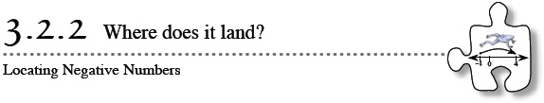
- 3-106. Find the missing value in each number sentence. Homework Help ✎
  - 4 −3.5 + 3.5 − 1 = _____
  - −2 + 4 + 4 = _____
- 3-107. Find common denominators and calculate each of the following sums. Homework Help ✎
  - 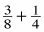
  - 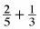
  - What is the least common multiple of 8 and 4? Of 5 and 3?
  - Explain how finding the least common multiple of two numbers can help you add fractions.
- 3-108. In parts (a) and (b) below, copy the vertical number lines and use them to show the solution to the problems. Homework Help ✎
  - 5 − 2 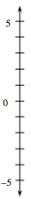
  - 2 + 1 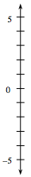
  - Show how to find the answer to −3 + 4 − 1 on a number line.
  - Rachel said that −4 −3 ends up being positive because two negatives always give a positive. Draw the problem on a number line, and then explain whether you agree or disagree with Rachel.
- 3-109. The yearbook staff at Jefferson Middle School has been busy taking pictures. Of the 574 pictures the staff members have taken, only 246 of the pictures will make it into the yearbook. Approximately what portion of the pictures that were taken will make it into the yearbook? Use a complete portions web to show your answer. Show your work. Homework Help ✎
- 3-110. Carefully copy the graph and point A on a piece of graph paper. 3-110 HW eTool (Desmos). Homework Help ✎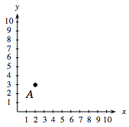
  - Plot the points listed below. Then connect them in the order given and connect point D to point A.
A (2, 3), B (3, 7), C (7, 7) , D (8, 3)
  - What is the name of the shape that you drew?
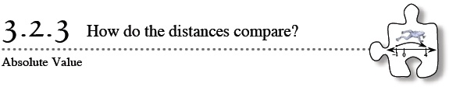
- 3-118. Simplify the following expressions. Show your work. Homework Help ✎
  - 8.23 + 10.9
  - −6−9
  - 8 − 3 − 4
  - 0−3
  - 15−20
  - −9 + 14
  - 5−9
- 3-119. Solve the number puzzles below. 3-119 HW eTool Homework Help ✎
  - If I add 9 to my number, I get 6. What is my number?
  - If I start at –5 on a number line and end up at –8, what direction did I move? How many units did I move?
  - If I moved up 8 and then moved down 8, what can you tell me about my ending position?
- 3-120. You can see in the examples below that not all number lines increase by one unit from mark to mark. Sketch the number lines on your paper and fill in the missing numbers. Homework Help ✎
  - 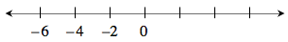
  - 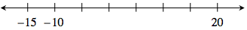
  - 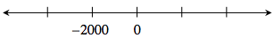
- 3-121. A triangular flower bed (space for planting flowers) needs a thin metal border all the way around it. The sides are 7 feet, 6 feet, and 9 feet long. Homework Help ✎
  - How many feet of border should be purchased? Make a sketch and show your work.
  - If borders cost $8.75 per yard (and only whole numbers of yards can be purchased), how much would the border cost?
- 3-122. One of the topics you will review in this course is reading graphs. Look at the graph below. This graph shows positive and 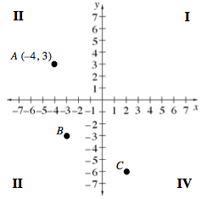negative values on both axes. It divides the plane into four parts, or quadrants. It is called a four-quadrant graph. The quadrants are numbered I, II, III and IV in a counter-clockwise manner as shown. Homework Help ✎
  - The coordinates (the x- and y- values) for point A are (–4, 3). Explain how these numbers tell you the position of pointA using the graph.
  - Name the coordinates (x, y) for points B and C.
  - If Deepak moved from point A 8 units to the right and 10 units down, at what point on the graph would he end up? Which quadrant is the new point in?
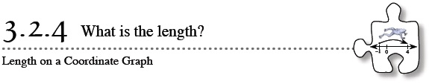
- 3-128. Evaluate each absolute value expression below. Homework Help ✎
- 3-129. Name the endpoints of the segment shown on the graph below. What is the length of the segment? Write an absolute value expression to show how to calculate the length of the segment. Homework Help ✎
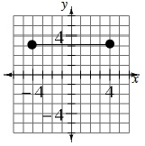
- 3-130. Find the greatest common factor and the least common multiple of each of the following sets of numbers. Homework Help ✎
  - 12 and 7
  - 3, 15 and 9
  - 20 and 30
- 3-131. The following representations have been drawn to represent portions of a 100% block. Write each of the portions in at least two different forms. Homework Help ✎
  - 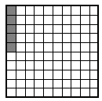
  - 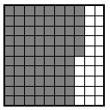
- 3-132. This problem is a checkpoint for addition and subtraction of fractions. It will be referred to as Checkpoint 3.
- Compute each sum or difference. Simplify if possible. Homework Help ✎
- Check your answers by referring to the Checkpoint 3 materials.
- If you needed help solving these problems correctly, then you need more practice. Review the Checkpoint 3 materials and try the practice problems. Also consider getting help outside of class time. From this point on, you will be expected to do problems like this one quickly and easily.

