Chapter 5 Homework
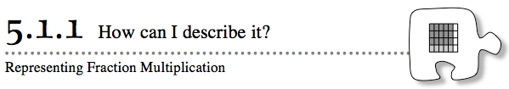
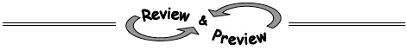
5-4. The diagrams below show the portion of another class mural that Josephine was supposed to paint and how much she actually did paint. Use the pictures to answer the questions that follow. Help (Html5)⇔Help (Java)
The portion Josephine was supposed to paint: | The portion Josephine actually painted:
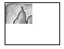
- Approximately what portion of the painting was Josephine supposed to paint?

- Approximately what fraction of her assigned portion did Josephine actually complete?

- Write a product to show what portion of the mural Josephine actually painted.
5-5. Draw a rectangle with a width of 8 units and a length of 6 units. Help (Html5)⇔Help (Java)
- What is the enlargement ratio if you enlarge the figure to have a width of 16 units and a length of 12 units?
- If you wanted to reduce the 8 by 6 rectangle by a ratio of, what would the dimensions of the new rectangle be?
5-6. Recall the definition of absolute value from the Math Notes box in Lesson 3.2.4. For each pair of points below, find the distance between the given points. Show your work using absolute value symbols. Help (Html5)⇔Help (Java)
- (13, 14) and (−3, 14)
- (−9, 1) and (−9, 11)
5-7. Change each fraction greater than one to a mixed number, and change each mixed number to a fraction greater than one. Help (Html5)⇔Help (Java)
- 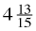
5-8. Simplify each of the following expressions. Be sure to simplify each of your answers as much as possible. Write any answers greater than one as mixed numbers. Help (Html5)⇔Help (Java)
- 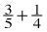
- 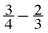
- 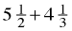
- 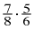
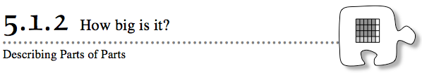
5-13. Use a portions web to rewrite each decimal as a percent, as a fraction, and with words. Help (Html5)⇔Help (Java)
a. 0.2
b. 0.05
c. 1.75
d. 0.002
5-14. Find each of the parts of parts described below. For each one, create a diagram that demonstrates your thinking. Help (Html5)⇔Help (Java)
- of
- 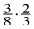
- of 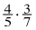
- 4/5 times 3/7
5-15. Simplify each expression. Help (Html5)⇔Help (Java)

5-16. Kenali wants to cut a piece of rope into several equally-sized pieces and then have a 10-foot piece remaining. Write an algebraic expression to represent the length of each rope shown in the diagrams below. Then use the equation you create to help Kelani figure out how long to make each of the equally-sized pieces. Help (Html5)⇔Help (Java)

- A 25-foot piece of rope (find n).
- A 310-foot piece of rope (find x). 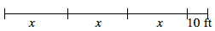
- A 13-foot piece of rope (find j).
5-17. Convert each mixed number to a fraction greater than one, or each fraction greater than one to a mixed number. Help (Html5)⇔Help (Java)
- 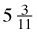
- 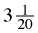
- 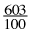
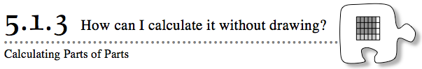
5-24. Write each of the mixed numbers below as a fraction greater than one, and write each of the fractions greater than one as a mixed number. Include a diagram to explain each answer. Help (Html5)⇔Help (Java)
- 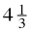
5-25. Calculate each of the following parts of parts. Help (Html5)⇔Help (Java)
- of
- of
5-26. Multiply each pair of numbers below. Help (Html5)⇔Help (Java)
a. 68 · 100
b. 0.68 · 100
c. 6.8 · 1000
d. Describe in words what is happening to the decimal point in each problem, (a) through (c) above.
5-27. On your own graph paper, draw a rectangle with a width of 6 cm and a height of 8 cm.
- Draw a similar rectangle that is enlarged 300%. Help (Html5)⇔Help (Java)
- Draw a similar rectangle with lengths that are of the original lengths.
5-28. Sophie claims that whenever she increases the perimeter of a rectangle, its area increases. Help (Html5)⇔Help (Java)
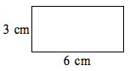
- She showed the rectangle at right and said, “If I make the base twice as long, then the area increases.” Is her statement correct for this figure? Draw a diagram of the rectangle she described and explain whether the area is greater or less than the rectangle at right.

- Is her claim about the relationship of area and perimeter correct for all figures? For example, is there any way that she could have a rectangle with a greater perimeter than the figure in part (a) but with the same area? Give examples and explain your reasoning.
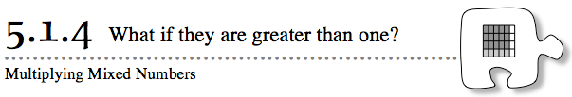
5-34. Complete the diagram below and write the multiplication problem and answer that would go with it. Help (Html5)⇔Help (Java)
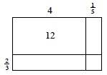

5-35. Draw a rectangle. Label the lengths of the sides. Enlarge it so that the ratio of sides of your new rectangle to the original one is . What are the new dimensions? Help (Html5)⇔Help (Java)
5-36. When making estimates, it is sometimes useful to approximate unfamiliar fractions by comparing them to numbers that are more familiar to you. Help (Html5)⇔Help (Java)
Copy the number line below on your paper, including the dots. Keep the dots in the same positions. Label each dot with one of the fractions from the list given below.
- Which of these fractions are greater than or equal to 1?
- Which of these fractions are close to the number 1?
- Which of these fractions are close to ?
- Which of these numbers are close to 0?
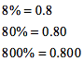
5-37. Richard’s strategy for changing a percent to a decimal is to put the decimal point in front of the percent number. An example of his work is shown at right. Do you agree with Richard’s method? Explain your reasoning. Help (Html5)⇔Help (Java)
5-38. Divide each pair of numbers below. Help (Html5)⇔Help (Java)
- 75 ÷ 10
- 75 ÷ 100
- 75 ÷ 1000
- Describe in words what happens to the decimal point in each problem , (a) through (c) above.
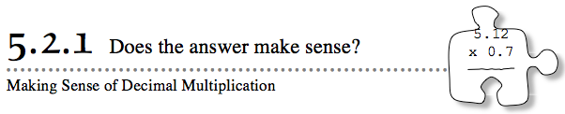
5-48. Ethan decided to give 10% of his monthly income to charity. This month, he wrote the calculation at right. Explain why this calculation is appropriate and finish it for him. How much money should he give this month? Help (Html5)⇔Help (Java) 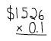

5-49. Melissa wants to re-sod her yard (replace the grass). Her backyard has a rectangular lawn area that measures 24 feet by 18 feet. Her front yard has two rectangular areas, one of which measures 18 feet by 14 feet. The other measures 12 feet by 14 feet. How many square feet of sod does Melissa need? Show all of your work clearly. Help (Html5)⇔Help (Java)
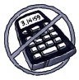
5-50. Without using a calculator, simplify the following decimal expressions. Help (Html5)⇔Help (Java)
a. 0.04(0.7)
b. (1.8)(0.3)
5-51. Four pieces of rope of unknown (but equal) length and 10 more feet of rope are attached together. The resulting rope is 30 feet long. Help (Html5)⇔Help (Java)
- Draw a diagram to represent this problem.
- How long is each of the pieces of rope that is not 10 feet? Show how you know.
5-52. Complete the portion web for each fraction below. Help (Html5)⇔Help (Java)
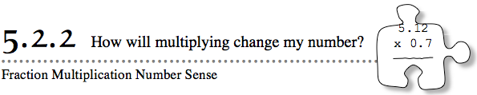
5-61. Multiply to find the percents below. Help (Html5)⇔Help (Java)
a. 8% of 150
b. 8.5% of 70
5-62. Genevieve is an architect and has just finished the plans for a new library. She built a scale model to take to a planning meeting. The City Council members love her design so much that they have asked her for two new models.
Help Genevieve decide how she will calculate the measurements of each new model to satisfy each of the given conditions. Help (Html5)⇔Help (Java)
- The council wants a model much smaller than Genevieve’s original model to fit in a scale model of the entire city.
- The council wants a model slightly larger than the one Genevieve built to sit on a stand at the entrance of the old library building.
5-63. Billy and Ken, the school’s cross-country stars, were each running at cross-country practice. Billy was going to run of the training course, and Ken was going to run of the course. However, during practice it started raining, so they could not finish their runs. Billy had finished of his run, while Ken had finished of his run. Draw a picture to determine which cross-country star ran the farthest. Help (Html5)⇔Help (Java)
5-64. Add or subtract the following pairs of fractions and mixed numbers. Help (Html5)⇔Help (Java)
- 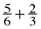
- 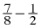
- 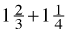
- 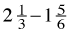
5-65. Find the missing side lengths of each rectangle, (a) and (c) or square (b) and (d). Help (Html5)⇔Help (Java)
- 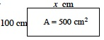
- 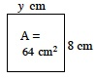
- 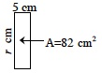
- 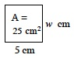
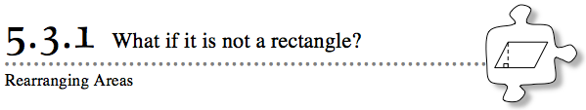

5-71. Bianca is trying to find the area of this rectangle. She already measured one side as 10 cm. Which other length(s) could she measure to use in her area calculation? Explain your reasoning. Help (Html5)⇔Help (Java)
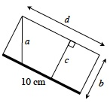
5-72. Zac is making cookies, but he does not have enough brown sugar to make a full recipe. The full recipe calls for cup of brown sugar.
If Zac has enough brown sugar for of the full recipe, how much brown sugar does he have? Help (Html5)⇔Help (Java)
- Represent the cup of brown sugar the recipe calls for with a diagram.
- Represent the portion of brown sugar that Zac has if he makes only of the recipe.
- What mathematical operation should Zac use to find the amount of brown sugar he has? Write an expression and then calculate its value.
5-73. Jack and Jill were each placing points on the grid shown at right. Jack’s points are the full circles, and Jill’s are the open circles. Help (Html5)⇔Help (Java) 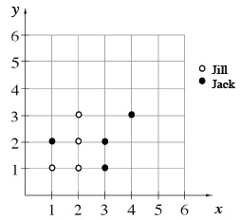

- Record Jack and Jill’s points as ordered pairs.
- Give the coordinates of one more point that Jill could draw so that she has four of her points in a row.
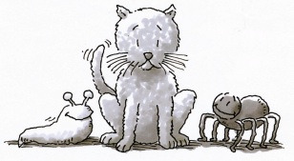
5-74. Complete each of following statements. Help (Html5)⇔Help (Java)
- If one cat has 16 whiskers, then seven cats will have whiskers.
- If three slugs have six eye-stalks, then two slugs will have eye-stalks.
- If eight spiders have 64 legs, then 5 spiders will have legs.
5-75. Draw generic rectangles to calculate each of the following products. Help (Html5)⇔Help (Java)
- 34 · 91
- 421 · 36
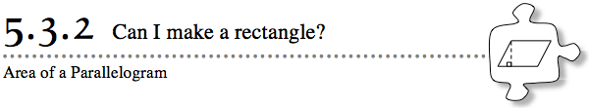

5-80. Use any of your new strategies to find the area of the parallelograms below. The information in the Math Notes box may help. Help (Html5)⇔Help (Java)
- 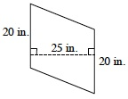
- 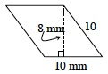
5-81. Additional Challenge: Jill lives 3 miles from school. One morning, her friend was giving her a ride. When they wereof the way to school, their car broke down and they had to walk the rest of the way. Draw a picture to help you figure out how far they walked. Help (Html5)⇔Help (Java)
5-82. For each of the following products, estimate the answer. Explain your reasoning. Then multiply each set of numbers to see how close you were. Help (Html5)⇔Help (Java)
- 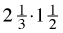
b. 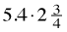
c. 3.1 · 2.7
5-83. Johanna is planting tomatoes in the school garden this year. Tomato plants come in packs of six. She needs 80 plants in the garden and already has 28. How many packs of plants will she need? Help (Html5)⇔Help (Java) 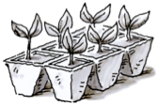
5-84. Are you ready for a number puzzle? Help (Html5)⇔Help (Java)
- Use the numbers 7, 5, 6, and 3, only once each, to create an expression that equals 75. You may use addition, subtraction, multiplication, and/or division, but you must use parentheses.
- Now use the Distributive Property to write an equivalent expression without parentheses. (You may use the numbers more than once or use different digits for this part only.)
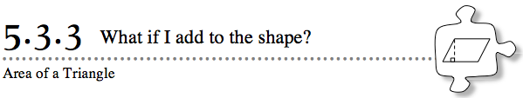
5-91. Find the area of each parallelogram below. Show all of your work. Use the Math Notes box in this lesson if you need help. Help (Html5)⇔Help (Java)
- 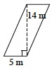
- 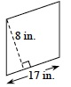
5-92. Find the area of the following triangles. Show all your work. Help (Html5)⇔Help (Java)
- 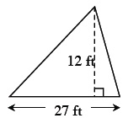
- 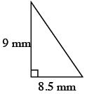
5-93. Graph the trapezoid A(6, 5), B(8, −2), C(−4, −2), D(−2, 5). Help (Html5)⇔Help (Java)
- Find the length of the bottom base (segment CB). Then find the length of the top base (segment AD). Use grid units.
- Find the distance between the two bases, which is called the height. Use grid units.
5-94. The first four multiples of 7 are 7, 14, 21, and 28. Use this example to help you as you answer the questions below. Help (Html5)⇔Help (Java)
- What are the first six multiples of 9?
- What are the first six multiples of 12?
- What is the least common multiple of both 9 and 12?
- What is the greatest common factor of both 9 and 12?
5-95. Draw a number line. Then draw and label a dot to show the position of each of the following numbers. Help (Html5)⇔Help (Java)
- 2.5
c. −2
d. 0.5
e. −1
f. −
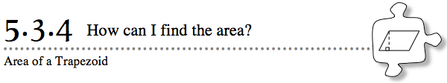
5-101. Choose any strategy to find the area of each shape below. Use the information in the Math Notes boxes for help. Assume that the shape in part (a) is a parallelogram and that the shape in part (b) is a trapezoid. Help (Html5)⇔Help (Java)

- 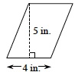
- 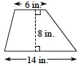
5-102. Find each sum. Help (Html5)⇔Help (Java)
- −3 + 7
- 7 + (−8)
- 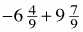
5-103. This problem is a checkpoint for multiple representations of portions. It will be referred to as Checkpoint 5.
For each portion of a whole, write it as a percent, a fraction, and a decimal. Also show it as a picture or situation. Use a portions web to organize your answers. Help (Html5)⇔Help (Java)
- 0.23
- seven-tenths
- 19%
Check your answers by referring to the Checkpoint 5 materials.
If you needed help solving these problems correctly, then you need more practice. Review the Checkpoint 5 materials and try the practice problems. Also consider getting help outside of class time. From this point on, you will be expected to do problems like this one quickly and easily.
5-104. Write an algebraic expression to represent the length of each segment shown below. Help (Html5)⇔Help (Java)
- 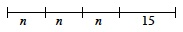
5-105. Simplify each of the following expressions without using a calculator. Then use a calculator to check your answers. Help (Html5)⇔Help (Java)
a. 0.045 + 1.2 + 62.003
b. 56.7 − 0.23
c. (7.8)(0.03)
d. 6.3 − 7.5

