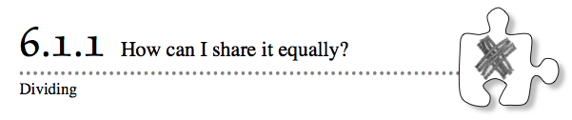
6-5. If you had 2 pieces of licorice to share equally among 3 people, how much licorice would each person get? Show your thinking clearly. Help (Html5)⇔Help (Java)
6-6. Calculate each of the following parts of parts. Help (Html5)⇔Help (Java)
- of
- of
6-7. Simplify each numerical expression. Help (Html5)⇔Help (Java)
- 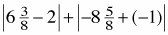
6-8. Find the area of each of these trapezoids. Show all of your steps. Help (Html5)⇔Help (Java)
- 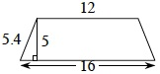
- 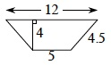
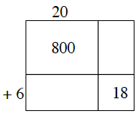

6-9. Consider the generic rectangle shown at right. Help (Html5)⇔Help (Java)
- Copy and complete the generic rectangle

- Write as many products as you can see in the rectangle. Find at least four. For each one, show the factors being multiplied, as well as the product.
6-10. If you had 12 pieces of licorice to share equally among 5 people, how much licorice would each person get? Be sure to show your thinking clearly. Help (Html5)⇔Help (Java)
6-11. Round each number to the specified place. Help (Html5)⇔Help (Java)
- 198.59 (ten)
b. 5,462.9554 (thousandth)
c. 724.82338 (tenth)
d. 851.392 (one)
6-12. For each of the following questions, draw a diagram to explain your answer. Help (Html5)⇔Help (Java)
- How many fourths are in one-half?
- How many sixths are in two-thirds?
- How many fourths are in six-eighths?
- How many halves are in 3?
6-13. Copy the number line and label the following numbers at their approximate place on the number line. Help (Html5)⇔Help (Java)
a.
b. 0.75
c.
d.
6-14. If 6 rabbits can eat 24 daisies, how many daisies would 4 rabbits eat? Help (Html5)⇔Help (Java)
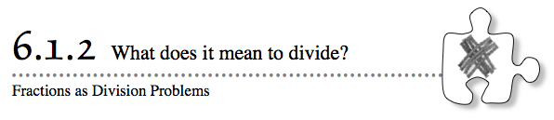
6-21. Show how to divide 9 pieces of licorice among 4 people. Help (Html5)⇔Help (Java)
6-22. Ashley paintedof her bathroom ceiling. Alex painted of the ceiling in the school library. Help (Html5)⇔Help (Java) 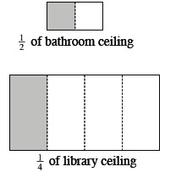
- Who painted the larger fraction of their ceiling?
- If the drawings at right accurately represent the relationship between the ceiling sizes, who painted more ceiling area?

- Explain why the answers for parts (a) and (b) should be different.
6-23. Together, Lucia and Ben have saved $150. Lucia saved $2 for every $1 that Ben saved. How much money did each person save? Help (Html5)⇔Help (Java)
6-24. Find each of the products in parts (a) through (d) below. Help (Html5)⇔Help (Java)
- 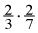
- 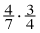
- 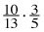
- 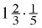
6-25. Write the points on the graph below as ordered pairs. Help (Html5)⇔Help (Java)
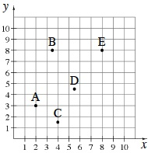
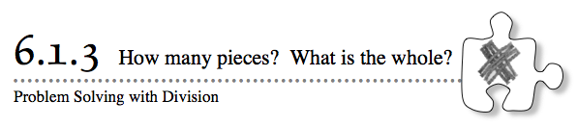
6-33. Use a ruler to draw a line exactly 4 inches long and then mark every inch. Help (Html5)⇔Help (Java)
- How many inches are in 4 inches?
- Now use the ruler to mark every inch. How many inches are in 1 inch?
- How many inches are in 2 inches? in 3 inches?
6-34. Draw a diagram that shows how to divide 9 pieces of licorice into packages that hold 5 pieces each. Then find 9 ÷ 5. Help (Html5)⇔Help (Java)
6-35. Audrey made the histogram below to show her recent bowling scores. Help (Html5)⇔Help (Java)
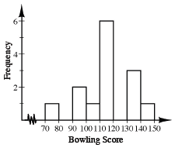
- How many games did she play in total?
- Between what two values did most of her scores fall?
Challenge: What portion of her scores fell between 130 and 140?
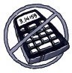
6-36. Multiply the following fractions. Help (Html5)⇔Help (Java)
- 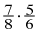
- 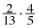
- 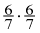
- 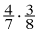
6-37. Graph and connect the points (1, 1), (1, 5), (4, 5) and (4, 1) in the order listed and then connect the last point you graphed to the first point. What is the length of each side? What is the area of the shape that is formed? Help (Html5)⇔Help (Java)
6-38. Draw a diagram to help calculate each of the following quotients (the answer to a divison problem). Help (Html5)⇔Help (Java)
- 4 ÷
- 6 ÷
6-39. Jesse has five meters of twine and needs to cut it into lengths that are each of a meter long. How many lengths will he have? Express this problem in a number sentence that uses division. Help (Html5)⇔Help (Java)
6-40. Arrange each of these fractions on a number line: 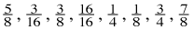. Help (Html5)⇔Help (Java)

6-41. Multiple Choice:If a pizza is split evenly among 3 people, which of the following is the most accurate description of the amount of the whole pizza each person should receive? Explain your choice. Help (Html5)⇔Help (Java)
- 0.33
b.
c. 33.3%
6-42. Draw generic rectangles to calculate each of the following products. What is each product? Help (Html5)⇔Help (Java)
- 11 · 33
- 111 · 333
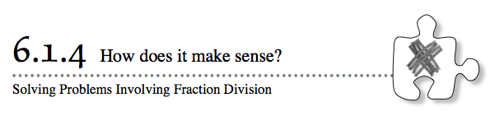
6-51. Name the coordinates of each point shown in the graph below using ordered pairs (x, y). Help (Html5)⇔Help (Java)
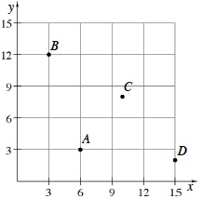
6-52. At the school’s fall bake sale, all of the pies were cut into 6 pieces, so each person who bought a piece bought of a pie. Each slice of pie sold for $1.00. How much money did the school make if all eleven pies were sold? (In other words, find 11 divided by .) Help (Html5)⇔Help (Java)
6-53. Find the area and perimeter of a rectangle that is 14.5 meters by 5.8 meters. Help (Html5)⇔Help (Java)
6-54. Express each of the following numbers as a product of its prime factors. Use exponents to represent repeated multiplication, when applicable. An example is given below. Help (Html5)⇔Help (Java)
40 = 2 · 20 = 2 · 2 · 10 = 2 · 2 · 2 · 5 = 2³ · 5
- 30
- 300
- 17
- 21
6-55. Copy the pattern below. Help (Html5)⇔Help (Java)
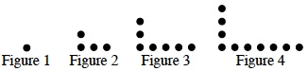
- Draw the fifth and sixth figures on your paper.
- Describe Figure 20.
- How many dots will be in Figure 20?
6-56. Graph each of the following points and connect them in order. Help (Html5)⇔Help (Java)
(1, 1), (1, 5), (5, 5), (5, 1), (3, 1), (3, 3), (2, 3), (2, 1), (1, 1)
- What is the area of the shape that was formed?
- What is the perimeter of the shape that was formed?
6-57. Ms. Perez is giving her class a pizza party because every student completed the school-wide book reading challenge. If an extra-large pizza costs $15 and serves 8 people, how much should Ms. Perez expect to pay for pizzas if her class has 28 students? Help (Html5)⇔Help (Java)
6-58. Solve each generic rectangle puzzle. Write your answer in the form:
(total length)(total width) = sum of individual area parts = total area. Help (Html5)⇔Help (Java)
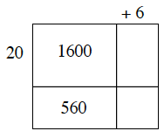
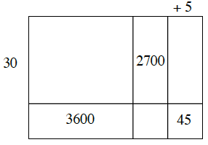
6-59. In each of these problems, assume that people divide the food evenly. Write your answer as a division problem in fraction form: . Help (Html5)⇔Help (Java)
- If two people share one soda, how much of the soda should each person get?
- If two people share three hamburgers, how much should each person get?
- If three people share a large box of fries, what part is each person’s share?
- Three people share seven brownies. How many brownies should each person get?
- Two people share five apple turnovers. How many turnovers should each person get?
- If five people share three cartons of chow mein, what is each person’s share?
6-60. Complete the web shown below to represent the portion 145% as a fraction, a decimal, and with words. Help (Html5)⇔Help (Java)
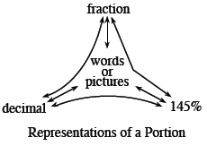
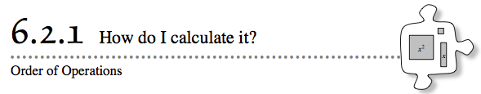
6-69. How can you check if the following two expressions are equivalent? Are they? Help (Html5)⇔Help (Java)
3(4x − 2) 12x − 2

6-70. A rectangle has an area of square centimeters and a length of 1.5 centimeters. What is the width? What is the perimeter? Help (Html5)⇔Help (Java)
6-71. Find the area of each trapezoid below. Help (Html5)⇔Help (Java)
- 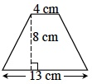
- 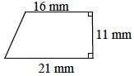
6-72. Simplify each expression. Help (Html5)⇔Help (Java)
- 16 − 5(3 − 1)
b. 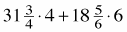
c. 3.45(2²) − 8.18 · 1
d. 4 · 5 −2² + 3(5 − 4)
6-73. Draw a number line and place each of the following numbers in its appropriate place on the line: −5, −2, 4, 6, −1, , −0.5. Help (Html5)⇔Help (Java)
6-74. Are the following expressions equivalent? Help (Html5)⇔Help (Java)
3(4x − 2) + 8 2(6x + 1)
6-75. Evaluate the expressions below using r = 3 and h = 5. Help (Html5)⇔Help (Java)
- 6h − 4
- 8r + h
- r²
6-76. For each of the following parts, write the completed set of fractions on your paper. Help (Html5)⇔Help (Java)
- Complete these fractions to make them close to 0: 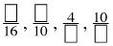.
- Rewrite these fractions to make them close to : 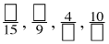.
- Rewrite these fractions to make them greater than 1 but less than 2: 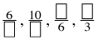.
6-77. Include a sketch and a division number sentence to support each of your answers below. Help (Html5)⇔Help (Java)
- How many fifths are there in a whole?
- How many thirds are there in 2?
- How many are there in 4?
6-78. What portion of one dollar is represented by each of the following sets of coins? Express each answer both as a fraction and as a percent. Help (Html5)⇔Help (Java)
- One quarter
- Three dimes
- Eight nickels
- 23 pennies
- Five quarters
- Nine dimes

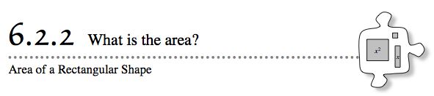
6-86. Sketch the shape made with algebra tiles below on your paper. Then answer parts (a) and (b) below. Help (Html5)⇔Help (Java)
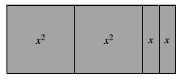
- Find the area of the shape.
- If the algebra tiles were rearranged into a different shape, how would the area change?
6-87. Your team forgot to clean up their algebra tiles and now they are all over your desk. Help (Html5)⇔Help (Java)
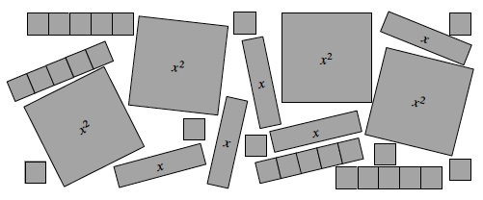
Sort the tiles so that they are in groups that are all the same. Write a sentence explaining how many of each type of tile you have.
6-88. Draw a number line from 0 to 2. Then write the following numbers in their correct place on the number line. Help (Html5)⇔Help (Java)
0.2 1.5 1.9 1.09 1.19
6-89. Find the perimeter and area of each figure. Help (Html5)⇔Help (Java)
- 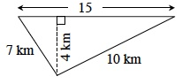
- 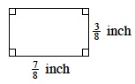
6-90. There were 25 words on a recent vocabulary test in English class, and Owen got four words wrong. What percent did he get correct? Help (Html5)⇔Help (Java)
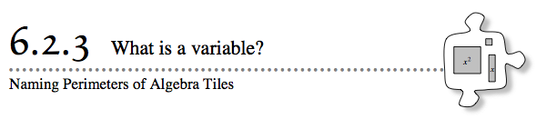
6-96. Copy the diagrams of algebra tiles below on your paper. Then find the perimeter of each shape. Help (Html5)⇔Help (Java)
- 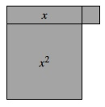
- 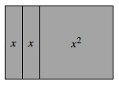
6-97. Jack and Jill are playing a Mystery Game. They are trying to get four tiles of the same color in a row, column, or diagonal. Four in a row wins the game. Help (Html5)⇔Help (Java) 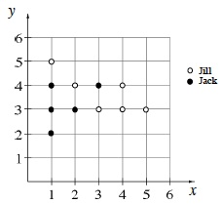
- List the coordinates of the points that they have already played, as shown at right.

- Give two more points, one to Jack and one to Jill, so that either one might win.
6-98. Molly and Nancy disagree about the value of the expression 2 + 3 · 4. Molly thinks it is 20, and Nancy thinks it is 14. How could each girl have calculated her answer? Who is correct? Help (Html5)⇔Help (Java)
6-99. Show how to divide 3 pieces of licorice among 4 people. How much does each person get? Help (Html5)⇔Help (Java)
6-100. Recall that a factor of a number divides the original number and leaves no remainder. For example, 4 and 6 are factors of 12. Help (Html5)⇔Help (Java)
- Find all factors of 24.
- Find the smallest number that has 1, 2, 3, 4, and 5 as factors. What is the special name for this number?
C. Find the second smallest number that has 1, 2, 3, 4, and 5 as factors.
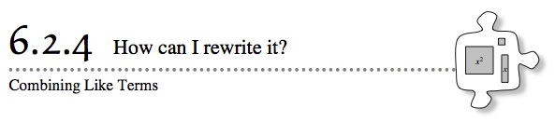
6-106. Find the perimeter and area of each figure made of algebra tiles below. Help (Html5)⇔Help (Java)
- 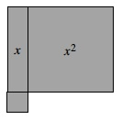
- 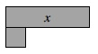
- 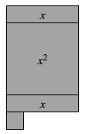
6-107. Sketch the collection of algebra tiles that is described by the following expression. Rewrite the area of the collection by combining like terms. Help (Html5)⇔Help (Java)
7x + 2x² + 3x² + 3 + x
6-108. Represent each of the following numbers two ways: by drawing an area model and by using a number line. Help (Html5)⇔Help (Java)
- 1
- 125%
6-109. Answer each of the questions below. Help (Html5)⇔Help (Java)
- How many eighths are in 5? Use your answer to rewrite 5 in the form .
- How many fifths are in 6? Use your answer to rewrite 6 in the form .
6-110. Evaluate the expressions below for the given values of the variables. Help (Html5)⇔Help (Java)
- 6j − 3 for j = 4
- b² + 5 for b = 3
- 8 + 4k for k = 3.5
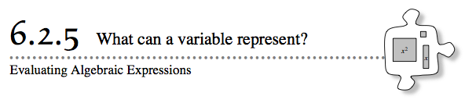
6-115. Sketch the algebra-tile shape at right on your paper. Write an expression for the perimeter of the shape. Then find the perimeter for each of the given values of x. Help (Html5)⇔Help (Java)
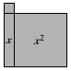
- x = 7 units
- x = 5.5 units
- x = units

6-116. Arrange the numbers below from least to greatest. Help (Html5)⇔Help (Java)
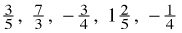
6-117. Copy the diagram at right on your own graph paper. Then enlarge or reduce it by each of the following ratios. Help (Html5)⇔Help (Java) 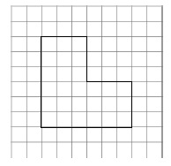

6-118. Molly is raising cows. She has a pasture for them that is 0.65 square miles in area. One dimension of the pasture is 0.4 miles long. Help (Html5)⇔Help (Java)
- What is the length of the other side of the pasture?
- How much fencing will she need to go around the pasture?
6-119. This problem is a checkpoint for locating points on a number line and a coordinate plane. It will be referred to as Checkpoint 6.
In part (a), indicate the approximate location of each number on a number line. In part (b), tell the name of each point in the coordinate plane. Help (Html5)⇔Help (Java)
−2, 4, −1.7, , −0.2, 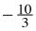, 4, 150%
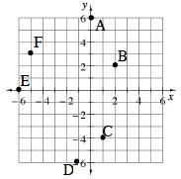
Check your answers by referring to the Checkpoint 6 materials.
If you needed help solving these problems correctly, then you need more practice. Review the Checkpoint 6 materials and try the practice problems. Also consider getting help outside of class time. From this point on, you will be expected to do problems like this one quickly and easily.

