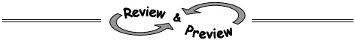
- 1-3. Mathography, Part 1: A mathography is a lot like your life history, except that it is focused on mathematics in your life. On the first page of the Lesson 1.1.1B Resource Page, answer the questions about yourself and your experience with mathematics. Homework Help ✎
  - Read the instructions for the “Personal Data” section (reprinted below). Write down a few planning ideas, then get a separate piece of paper and write about yourself.
Personal Data: Tell your teacher about yourself. You may wish to include things like how many siblings you have, people you live with, sports you enjoy, favorite subjects in school, hobbies, and other topics you like.
This is the first paper you will turn in to your teacher. Be sure to use your best writing skills. You can use the lines on the resource page to list your ideas, but write your full response on a separate piece of paper.
  - Read the introduction to the “Your Math History” section (reprinted below). Then complete the tables, graph, and number lines on the resource page.
Your Math History: Do you remember Kindergarten? How about 1st grade? Take a moment to recall as much as you can about each grade you have completed so far. Use what you remember to fill in the tables. You may be asked to add to your tables and graph at the end of this year.
- 1-4. Mathography, Part 2: You will complete your mathography on the second page of the Lesson 1.1.1B Resource Page. Homework Help ✎
  - Ask your parent or other adult caretaker to complete the “For the Grownup” section.
    - For the Adult: Please write a note to your student’s math teacher about your student’s best academic and other qualities and strengths.
  - Now complete the number lines and the three lists of goals in the “For the Student” section of the resource page
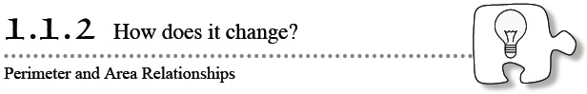
- 1-10. Janelle wants to challenge you to a “Toothpick and Tiles” game (described in problem 1-8). Using exactly four tiles, solve her challenges below. Justify your answers with pictures and labels. 1-10 HW eTool (CPM) Homework Help ✎
  - Create a tile pattern where the number of toothpicks is exactly double the number of tiles.
  - Create a tile pattern where the number of toothpicks is more than double the number of tiles.
- 1-11. In this lesson, you looked at the number of tiles and number of toothpicks used to form shapes made of square tiles as you played the “Toothpick and Tiles” game. The math words that also describe the number of tiles and toothpicks are area and perimeter. Read the Math Notes box for this lesson to review how area and perimeter are related to tiles and toothpicks, then answer the questions below. 1-11c HW eTool (CPM) Homework Help ✎
  - Find the area and perimeter of the figure below.
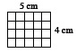
  - Find the area and perimeter of the rectangle below.
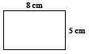
  - Now design your own shape with 5 square tiles.
Record the perimeter and the area.
- 1-12. Consider the first three figures of the pattern below. Homework Help ✎
- 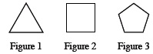
  - On your own paper, draw what Figure 4 of this pattern should look like.
  - Using words, describe what Figures 5 and 6 should look like.
  - Using words, describe how the pattern is changing.
- 1-13. Vi is trying to figure out how a square can be divided into four equal parts. Show her at least three different ways to divide a square into four equal parts. Homework Help ✎
- 1-14. The band students at Tolt Jr. High and Maywood Middle School have been invited to participate in the Evergreen Music Festival in Seattle. Each group has decided to have a car wash to raise money to pay for the trip. Use the graph below to answer the following questions. Homework Help ✎
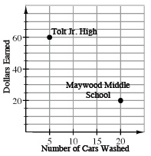
  - Which school washed more cars? How do you know?
  - Which school has raised the most money so far? How do you know?
  - Additional Challenge: Find how much each school is charging to wash a car. Show your work to justify your answer]
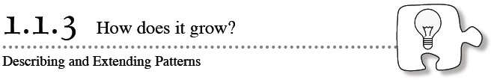
- 1-19. Study the dot patterns in parts (a) and (b) below. Assume that each pattern continues to increase by the same number of dots and in the same locations for each figure. For each pattern, sketch the 4th and 5th figures and then predict how many dots will be in the 100th figure. 1-19a & 1-19b HW eTool (CPM). Homework Help ✎

  - 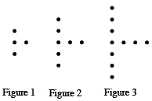
  - For each pattern, explain how you made your prediction for the 100th figure.
- 1-20. The value of a decimal becomes clearer when the place value is spoken or written as the number it names. For example, 0.1 makes more sense if it is read as “one-tenth” rather than “zero point one.” Homework Help ✎
  - Write the following numbers in words so that the place value can be identified.
0.4 1.3 0.56 2.008
  - Now reverse your thinking. Write the decimals that go with the following words.
thirty-five hundredths three and two-tenths six-hundredths
- 1-21. Find the perimeter of each figure below. The markings on part (b) mean that the lines are parallel. The markings on part (e) show that all sides are the same length. As you find each perimeter, be sure to show your work. Homework Help ✎
  - 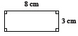
  - 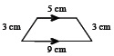
  - 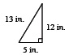
  - 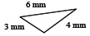
  - 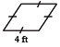
  - 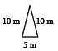
- 1-22. For each shape drawn in problem 1-21, choose one of the labels below that best describes that shape. Be as specific as you can. Look in the glossary of this book for more information if you do not remember what one of the words describes. Homework Help ✎

right triangle | scalene triangle | obtuse triangle
isosceles triangle | rhombus | rectangle
square | trapezoid | hexagon
- 1-23. Use the bar graph below to answer the following questions. Homework Help ✎
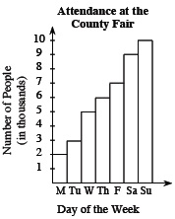
  - How many people attended the fair on Tuesday?
  - Which day had the largest attendance?
  - What was the total attendance for the week?
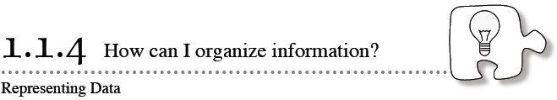
- 1-28. The table at Below shows data for winter temperatures in Urbana, IL. You will brainstorm questions that could be answered using the data. Homework Help ✎
Year | Avg. Temp. (ºF) |  | Year | Avg. Temp. (ºF)
1990 | 29 |  | 2000 | 31
1991 | 28.7 |  | 2001 | 24
1992 | 33.7 |  | 2002 | 34.1
1993 | 28.3 |  | 2003 | 26.1
1994 | 24.9 |  | 2004 | 27.8
1995 | 30.6 |  | 2005 | 31.3
1996 | 26.3 |  | 2006 | 31.3
1997 | 23.8 |  | 2007 | 28.6
1998 | 34.6 |  | 2008 | 27.4
1999 | 31.8 |  | 2009 | 25.2
  - Create a question that could be answered by using all of the data.
  - Create a question that could be answered using just some of the data.
  - How could you organize the data to answer your questions? Write you answer using complete sentences.
- 1-29. Use the histogram below to answer the following questions. The histogram contains the amount of snowfall in Urbana, IL during winter from 1990 – 2009. Homework Help ✎
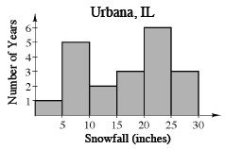
  - Which range of snowfall measurements occurred most often?
  - Were there any years with unusually high or low snowfall amounts?
  - Half of the years had snowfall amounts above how many inches?
- 1-30. Copy the number patterns below and write the next four numbers in the pattern. Assume the pattern continues as shown. Describe the pattern in words. Homework Help ✎
  - 2, 7, 12, 17, 22, ___, ___, ___, ___
  - 1, 4, 9, 16, 25, ___, ___, ___, ___
  - 1, 1, 2, 3, 5, 8, ___, ___, ___, ___
- 1-31. Round each number to the specified place. Read the Math Notes box in this lesson for a reminder of rounding to a given place value. Homework Help ✎
  - 5,294.6
(hundred)
  - 45,469.23
(thousand)
  - 7526.442
(hundredth)
  - 492.3069
(thousandth)
- 1-32. The graph below shows how far Ben is from home during a typical school day. Use the graph to answer the questions. Write your answers in complete sentences. Homework Help ✎
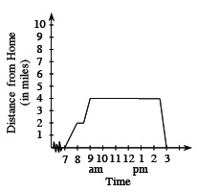
  - What was Ben doing between 7:00 a.m. and 8:00 a.m.?
  - What do you think Ben was doing between 9 a.m. and 2:30 p.m.?
  - What time did Ben leave to return to his starting point?
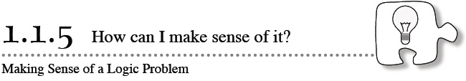
- 1-36. Bob and Mark decided to try the peanut and raisin investigation at home. Bob started with 10 peanuts on his tray, and Mark started with 10 raisins on his tray, as shown in the diagram below. Homework Help ✎
- 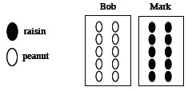
  - Mark gave 3 raisins to Bob, as shown in the diagram below. How does the number of peanuts and raisins on Bob’s tray compare to the number of peanuts and raisins on Mark’s tray?
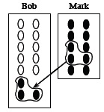
  - Copy the diagram below. Circle a group of any 3 peanuts and raisins on Bob’s tray. Besure to circle some of each for a total of 3. Then give them to Mark. Does Bob now have more of Mark’s raisins, or does Mark have more of Bob’s peanuts?
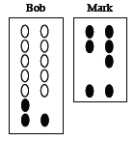
  - Now start from the beginning and repeat parts (a) and (b) assuming that 8 (instead of 3) snack items are handed from one student to the other. Explain your results.
- 1-37. Eli walked 12 feet down the hall of his house to get to the door. He continued in a straight line out the door and across the yard to the mailbox, a distance of 32 feet. He came straight back across the yard 14 feet and stopped to pet his dog. Homework Help ✎
  - Draw a diagram of Eli’s walking pattern.
  - How far has he walked?
  - How far from the house is he now?
- 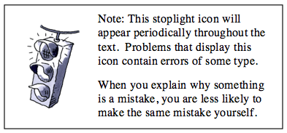1-38. Nadine and Diondra were working together to divide a circle into three equal parts. They came up with the diagrams shown below. Tanisha said, “One of these pictures is wrong.” Homework Help ✎
- What do you think? Is one picture incorrect? If so, which one? Why?
  - 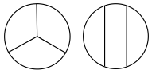
- 1-39. Find a pattern in each number sequence below. Then use your pattern to generate the next five numbers in the sequence. Explain the pattern. Homework Help ✎
  - 2, 5, 3, 6, 4, ____, ____, ____, ____, ____
  - 100, 99, 97, 94, 90, ____, ____, ____, ____, ____
- 1-40. Round each number to the specified place. Homework Help ✎
  - 33.54296 (ten thousandth)
  - 307,407 (thousand)
  - 285.39154 (hundredth)
  - 6811.09 (ten)
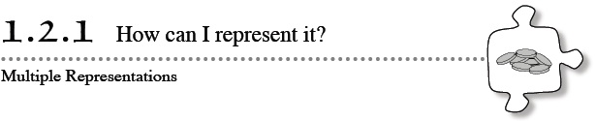
- 1-46. Match each of the following descriptions of pennies with its possible numeric expression. Then calculate the value of each expression. Homework Help ✎
1. 8(12) + 7 | 2. 6(20) + 5 | 3. 11(10) + 7 | 4. 9(12) + 5
a. 11 piles of 10 pennies with 7 leftover pennies
b. A rectangular array of pennies that is 9 pennies long and 12 pennies wide with 5 leftover pennies
c. 8 stacks of 12 pennies with 7 leftover pennies
d. A rectangular array of pennies that is 6 pennies wide and 20 pennies long with 5 leftover pennies
- 1-47. Write one whole number or one fraction in each blank to make each statement true. Homework Help ✎
  - One hundred pennies equals ____ dollar(s).
  - Two hundred pennies equals ____ dollar(s).
  - Fifty pennies equals ____ dollar(s).
  - Ten pennies equals ____ dollar(s).
  - One penny equals ____ dollar(s).
- 1-48. Matthew’s mother asked him to go to the store for her. To get to the store, he walked seven city blocks. He caught the bus and rode 13 blocks. He got off and walked one and a half blocks to the store. He purchased the items his mother wanted and returned home the same way. How many total blocks did he travel? Homework Help ✎
- 1-49. Which numbers make these division problems correct? Replace each box and triangle with a single-digit number. Homework Help ✎
  - 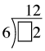
  - 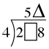
- 1-50. A line segment is a piece of a straight line. On your paper, draw two line segments that are the same length and each about as long as a pen. Homework Help ✎
  - Draw marks on the first line segment to show how you can divide it into eight equal lengths.
  - Draw marks on the second line segment to show how you can divide it into five equal lengths.
  - Was one of these tasks easier than the other? Which one? Why?
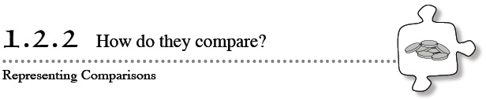
- 1-57. Which is greater: three sets of (5 − 2) or two sets of (2 + 3)? Draw diagrams to support your conclusion. Homework Help ✎
- 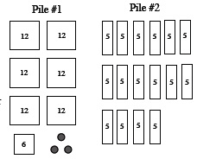1-58. The diagrams at right represent piles of pennies. Homework Help ✎
  - Which pile has more pennies? Explain your reasoning.
  - Write two different number expressions to represent the number of pennies in each pile.
  - Write a number comparison (using > , < , or = ) to show if the number of pennies in one pile is greater than the other or if they are the same.
- 1-59. Connie is helping her mother gather together the loose change (coins) in their house. They have collected a large jar full of quarters and dimes. Connie wants to arrange the coins on the table to make it easy to know how much money they have. Homework Help ✎
  - On your paper, draw a diagram to show Connie how she can arrange her quarters and dimes to make her money easy to count.
  - Draw another arrangement that would also be easy to count.
  - Which of your arrangements do you think is easiest to count? Explain why.
- 1-60. Use your knowledge of place value to place the correct inequality sign (< or >) between each pair of numbers. Homework Help ✎
  - 16.5 ___ 16.52
  - 4.110 ___ 4.10
  - 5.963 ___ 5.9
  - Write the numbers given in part (b) in words.
- 1-61. Aria and 19 of her friends plan to go to a baseball game. They all want to sit together. Aria wants to order the seats in the shape of a rectangle, but she cannot decide on the best arrangement. She starts by considering one row of 20 seats.
- Draw a diagram showing Aria’s idea for a seat arrangement. Then draw all of the other possible rectangular arrangements for 20 seats. Label each arrangement with its number of rows and the number of seats in each row. Are all arrangements practical? Explain. Homework Help ✎
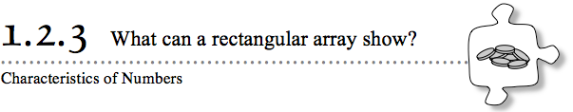
- 1-68. Harry had a pile of 48 pennies. He organized them into a rectangular array with exactly four rows with 12 pennies in each row. Homework Help ✎
- Draw diagrams to represent at least two other rectangular arrays he could use. Do you think there are more? Explain your thinking.
- 1-69. For each number of pennies below, arrange them first into a complete rectangular array and then into a different rectangular array that has a remainder of one (so there is one extra penny). Write an expression for each arrangement. Homework Help ✎
  - 10 pennies
  - 15 pennies
  - 25 pennies
- 1-70. How many pennies are represented by each expression below? Homework Help ✎
  - 3 + (4 · 5)
  - (4 · 3) + 7
  - (2 · 3) + 5 + (4 · 2)
- 1-71. Using whole numbers, fractions, and decimals, write at least eight addition equations that have a sum of 10. Write more if you can. Homework Help ✎
- 1-72. Use your knowledge of place value and decimals place the correct inequality sign (<, > ) between each pair of numbers. Homework Help ✎
  - 5.207 ___ 5.27
  - 3.006 ___ 3.06
  - 2.408 ___ 2.40
  - Round each number in part (b) to the nearest tenth
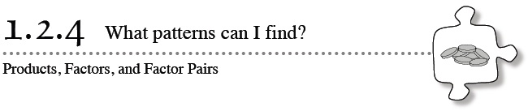
- 1-85. Use your multiplication table to figure out the missing number in each of the following number sentences. Each missing number is represented by n. 1-85 HW eTool (CPM) Homework Help ✎
  - 15n = 225
  - 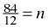
  - 11n = 143
  - 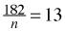
- 1-86. Jack has four tiles and wants to find out how many different shapes he can make with them. 1-86 HW eTool (CPM) Homework Help ✎
  - Sketch all of the arrangements that Jack could make with his tiles so that all of the tiles touch at least one other tile completely along a side. Assume that no tiles can overlap. How many arrangements are there?
  - For each diagram that you drew in part (a), find the area (the “tiles”) and the perimeter (the “toothpicks”). What do you notice?
- 1-87. Write four different fractions that are equal to 1. Use your calculator to check that you are correct. Homework Help ✎
- 1-88. Copy and complete the table of multiples below (count by 2’s and count by 3’s). Homework Help ✎
Two | 2 | 4 | 6
Three | 3 | 6
  - Write down all the numbers that appear in both rows. Describe any pattern(s) that you notice.
  - What is the smallest number that appears in both rows? This number is said to be the least common multiple of 2 and 3.
  - Find three more common multiples of 2 and 3.
  - Can you find the largest number that is a common multiople of both 2 and 3? If so, what is it? If not, explain why not.
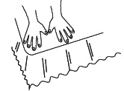
- 1-89. How many “hands” long is your bed? Homework Help ✎
  - Using your hands as units of measure, first estimate (without actually counting) the number of “hands” that you think will fit across the length of your bed.
  - Now measure and record the length of your bed using your hands.
- 1-90. Write a whole number in the box in the fraction that makes it. Homework Help ✎
  - Equal to 1.
  - Greater than 1.
  - Less than 1.
  - Equal to 0.
  - Greater than 100.
- 1-91. Study the dot pattern below. 1-91 HW eTool (CPM) Homework Help ✎
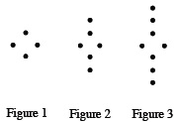
  - Sketch the 4th and 5th figures.
  - How many dots will the 50th figure have?
- 1-92. Write the prime factorization of each of the numbers below. Homework Help ✎
  - 24
  - 52
  - 105
- 1-93. Throughout this book, key problems have been selected as “checkpoints.” Each checkpoint problem is marked with an icon like the one at left. These checkpoint problems are provided so that you can check to be sure you are building skills at the expected level. When you have trouble with checkpoint problems, refer to the review materials and practice problems that are available in the “Checkpoint Materials”.
- This problem is a checkpoint for using place value to round and compare decimal numbers. It will be referred to as Checkpoint 1.
- Use your knowledge of place value to round the decimals to the specified place in parts (a) through (c). Place the correct inequality sign (< or >) in parts (d) through (f). Homework Help ✎
  - 17.1936 (hundredths)
  - 0.2302 (thousandths)
  - 8.256 (tenths)
  - 47.2__47.197
  - 1.0032__1.00032
  - 0.0089__0.03
- Check your answers by referring to the Checkpoint 1 materials.
- If you needed help solving these problems correctly, then you need more practice. Review the Checkpoint 1 materials and try the practice problems. Also, consider getting help outside of class time. From this point on, you will be expected to solve problems like this one quickly and easily.
- 1-94. Simplify the expressions in parts (a) through (f). Then answer the questions in part (g) using complete sentences. Homework Help ✎
  - 13 · 1
  - 1 · 55
  - 6 ·
  - 12 · 2
  - 4 ·
  - 14 ·
  - Use these examples to answer the following questions:
    - What happens when you multiply a number by one?
    - What happens when you multiply a positive number by a positive number less than one?
    - What happens when you multiply a positive number by a number greater than one?

